Fourth Year Progress report
(No more than two pages - please email completed report to jane.frew@eng.ox.ac.uk)

Name: Max Jaderberg College: Keble
Project Title: 10040 – An Intelligent Image
Supervisor: Andrew Zisserman
Description of project (200 words):

The project aims to create images displayed in your web browser that ‘knows’ about the objects it contains. Each object in the image will be tagged so that when you hover over the object in the image with the mouse cursor, information about the object is displayed and clicking it will go to its Wikipedia page.

The system will tag multiple objects in a single image using state of the art computer vision methods. The aim is to scale up the number of objects that can be recognised by the system to that of all the suitable objects that have images on Wikipedia, while keeping the retrieval time of matched objects to a minimum.

Results achieved so far (500 words, up to 5 figures):

So far I have achieved the following:
- Designed and built an ‘Intelligent Image’ HTML element.
- Designed and built the basic website framework.
- Set up a working object retrieval engine with a suitable database.
- Create a full working solution able to match multiple objects in an image.

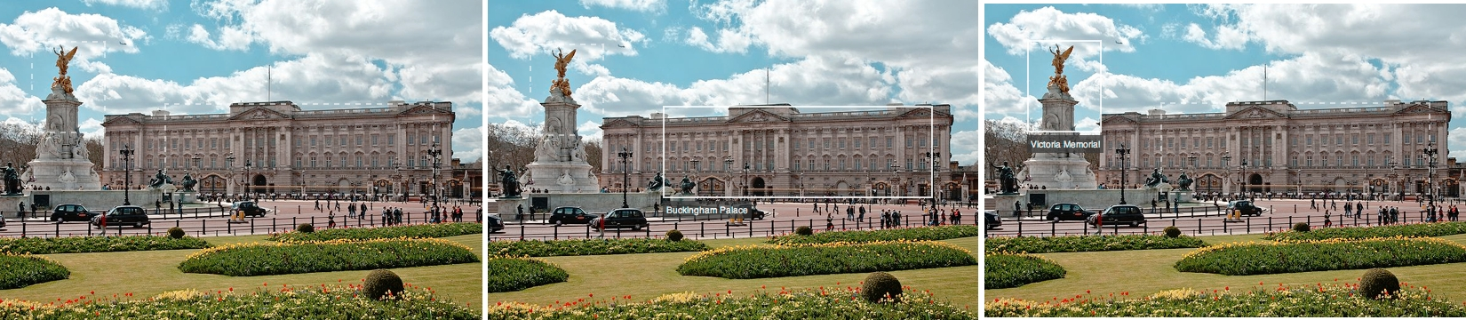
The ‘Intelligent Image’ HTML element is a block of HTML5 code, which when coupled with the associated CSS3 code for the styling, displays the query image which is to be matched with the objects tagged with rectangles which can be clicked on to go to the Wikipedia page for that object.
Figure 1 – An ‘Intelligent Image’ rendered in a browser. There are two tagged objects: Buckingham Palace to the right and the Victoria Memorial on the left. Centre and right image show the effect of hovering over each object.

This display of the tagged objects works very well in showing the user what is tagged and being intuitive to use. This early version of the code works perfectly in the browsers Chrome, Firefox and Safari, but not quite as desired in Internet Explorer (all versions). This is something that will require some more work.

The website which is required to upload an image to be tagged and deliver the tagged response has been created. The front end of the website is written in HTML5 and CSS3, using Javascript with the JQuery library for DOM manipulation and asynchronous communication with the webserver. Using an asynchronous method of communication between the server and the browser means that the browser does not have to refresh the page and less data is transferred. This makes for a quicker, more seamless user experience.

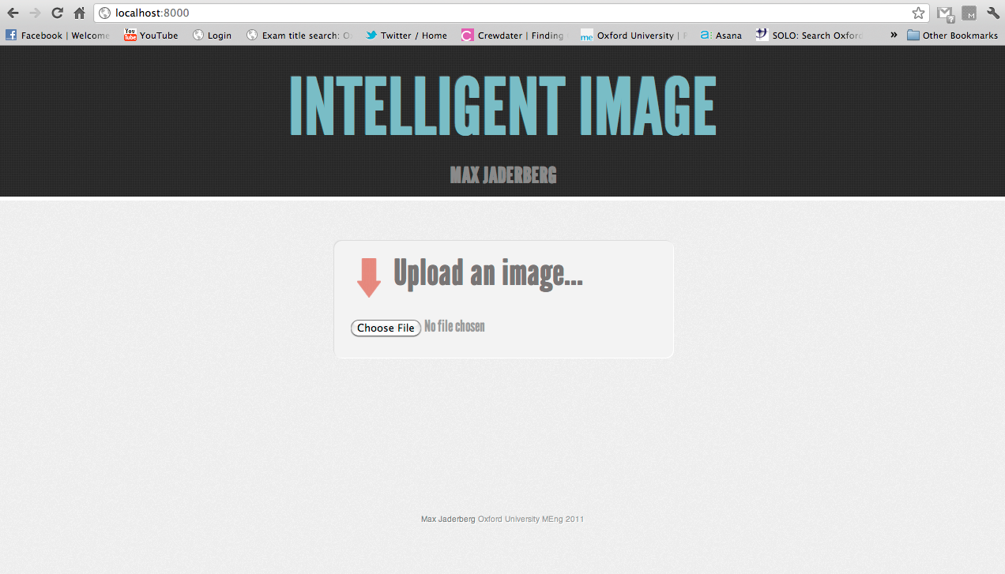
Figure 2 – The website for tagging images rendered in the Chrome browser.

The webserver itself is written in Python using a web framework called Django. This takes care of handling the HTTP requests and responses, the rendering of HTML pages, and creating and interfacing with the MySQL database of uploaded photos.

The object retrieval system has been created utilising vlfeat and implemented in MATLAB. The process matches the clustered SIFT features of the query image with those of the dataset (which are computed offline) weighted by their tf-idf score and spatially verified using RANSAC. Results have been proved using the Oxford dataset and testing against known results.

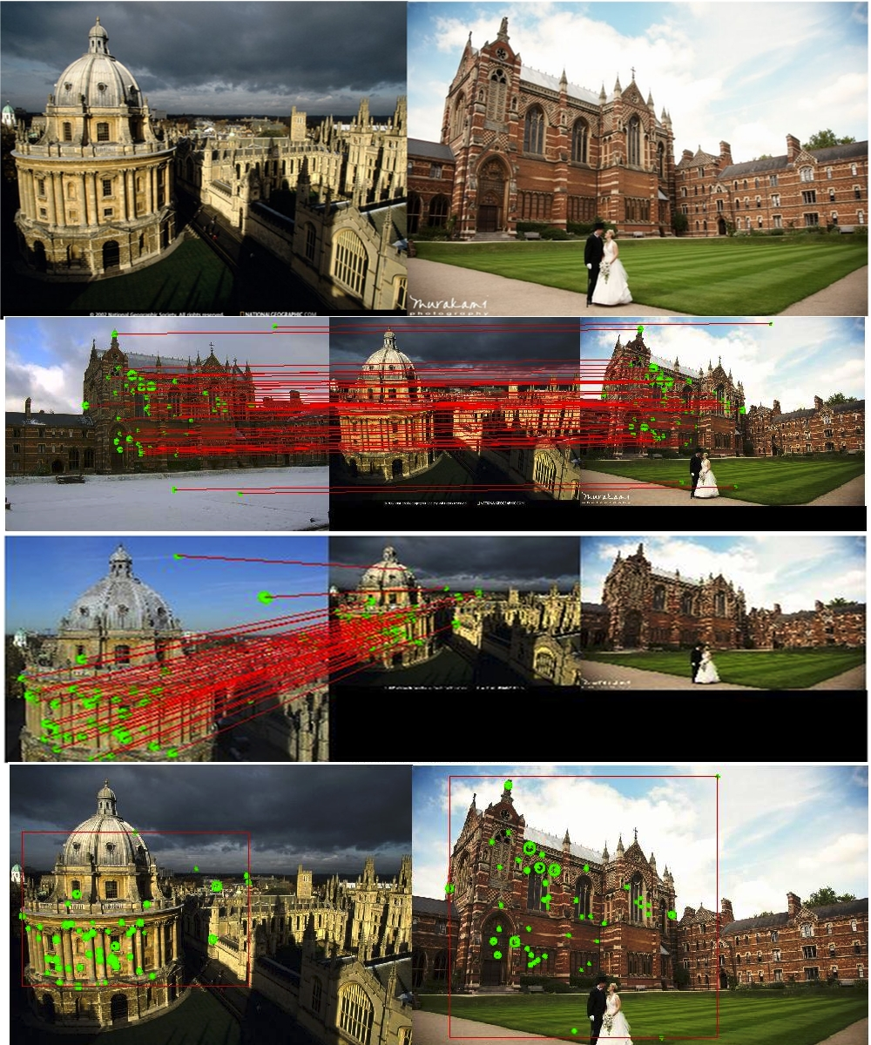
Figure 3 – Top: the query image (a collage of two objects). Centre: the matching of the two objects in the query image to those in the dataset. Bottom: the resulting tags on the query image produced in MATLAB.

Currently the system can match multiple objects from a dataset of 5000 images with 11 objects. Retrieval time takes around 20 seconds.

I have also written a module in Python and an associated module in MATLAB to connect the two. This allows the Django webserver to communicate with MATLAB, and so the website works fully, being able to match multiple objects in a query image (see Figure 4).


Figure 4 – The end tagged image using the website. Note: The Radcliffe Camera tag is being hovered over by the mouse, whereas the Keble tag is not.

The memory usage of the system has also been examined, and it has been concluded that more developments are needed in terms of memory management and data storage to allow the efficient scaling of the solution. At present I am working on moving much of the in memory data to a NoSQL database (MongoDB) and streamlining the matching process to increase the speed of matching and be able to start increasing the dataset of images and objects.

Problems: (Describe any potential problems and how you might address them)

- Limited hard drive space on my laptop means that the dataset must be stored on an external hard drive, which is slow to read and write data. Also the limited memory of my laptop may hinder explorations into scaling.
- Crawling, downloading and indexing all the images may take a very long time on a single computer, so long that mistakes and proper experimentation cannot be done.

Using a different computer/cluster as a server for development could solve these issues.
Future work:(Give a very brief description of what you will be doing in the remaining time.)

Week 7,8 MT: Integrating MongoDB and faster matching.

Winter break: Look into scaling and reducing memory usage. Start using a subset of the Wikipedia dataset for matching objects.

Week 1,2 HT: Continue development and scaling.

Week 3,4 HT: More scaling and indexing of Wikipedia images.

Week 5,6 HT: Look into filtering and suitability of Wikipedia images.

Week 7,8 HT: Work on architecture of deployment to increase speed and efficiency.

Spring Break: Begin write up. Test solution.

Week 1,2 TT: Write up and polish off.

Week 3,4 TT: Write up and polish off.

